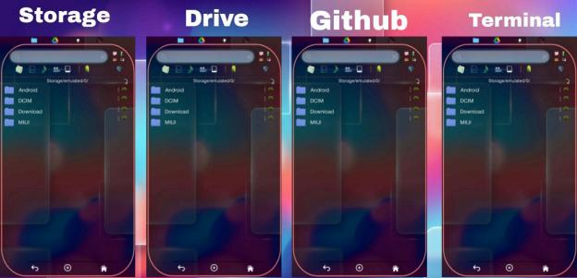

These are not fix panels below combinations ke sath bhi user kaam Kar sakta hain … ..
Combination will become =
S | S | S | S S | S | S | D S | S | S | G S | S | S | T S | S | D | S S | S | D | D S | S | D | G S | S | D | T S | S | G | S S | S | G | D S | S | G | G S | S | G | T S | S | T | S S | S | T | D S | S | T | G S | S | T | T
S | D | S | S S | D | S | D S | D | S | G S | D | S | T S | D | D | S S | D | D | D

S S S S S S S S S S

S S S S S S S S S S S S S S S S

S S S S S S S S S S S S S S S S
G T S D G T S D G T

S D G T S D G T S D G T S D G T

S D G T S D G T S D G T S D G T
 | D D D D D D D D D D  G G G G G G G G G G G G G G G G  T T T T T T T T T T T T T T T T |  | D D G G G G T T T T  S S S S D D D D G G G G T T T T  S S S S D D D D G G G G T T T T

D D D D D D D D D D D D D D D D  D D D D D D D D D D D D D D D D  D D D D D D D D D | S S S S S S S S S S S S S S S S  D D D D D D D D D D D D D D D D  G G G G G G G G G |  | S S S S D D D D G G G G T T T T  S S S S D D D D G G G G T T T T  S S S S D D D D G |  | S D G T S D G T S D G T S D G T  S D G T S D G T S D G T S D G T  S D G T S D G T S

D D D D D D D
D D D D D D D D D D D D D D D D
G G G G G G G G G G G G G G G G
G G
D G T S D G T

S D G T S D G T S D G T S D G T

S D G T S D G T S D G T S D G T
S D
 | G G G G G G G  T T T T T T T T T T T T T T T T  S S S S S S S S S S S S S S S S  D D |  | G G G T T T T  S S S S D D D D G G G G T T T T  S S S S D D D D G G G G T T T T  S S

G G G G G G G G G G G G G G  G G G G G G G G G G G G G G G G  G G G G G G G G G G G G | D D D D D D D D D D D D D D  G G G G G G G G G G G G G G G G  T T T T T T T T T T T T |  | S S D D D D G G G G T T T T  S S S S D D D D G G G G T T T T  S S S S D D D D G G G G |  | G T S D G T S D G T S D G T  S D G T S D G T S D G T S D G T  S D G T S D G T S D G T

G G G G  T T T T T T T T T T T T T T T T  T T T T T T T T T T T T T T T T  T T T T T |  | T T T T  S S S S S S S S S S S S S S S S  D D D D D D D D D D D D D D D D  G G G G G |  | T T T T  S S S S D D D D G G G G T T T T  S S S S D D D D G G G G T T T T  S S S S D |  | S D G T  S D G T S D G T S D G T S D G T  S D G T S D G T S D G T S D G T  S D G T S

T | G | D | D T | G | D | G T | G | D | T T | G | G | S T | G | G | D T | G | G | G T | G | G | T T | G | T | S T | G | T | D T | G | T | G T | G | T | T
T | T | S | S T | T | S | D T | T | S | G T | T | S | T T | T | D | S T | T | D | D T | T | D | G T | T | D | T T | T | G | S T | T | G | D T | T | G | G T | T | G | T T | T | T | S T | T | T | D T | T | T | G T | T | T | T
Panels ke upar Jo button diye Gaye he usse …



Panel ke upar ke logo per click karke..

2 - user ko just one panel hi fix dijaayegi … jese koi file manager open karta hain ek single … . local storage
Baki sari panels woh apne hisab se add Kar sake

IsKe liye hum alg alag size design karke option denge … User ko … . Jese picsart app me multiple Pics grid ka option aata hain … max 4 panel Lekin different views..
And all panels are flexible kisi bhi size ki Kar sakta hain … Also view lock bhi Kar sakta hain … .. & much more.

========================

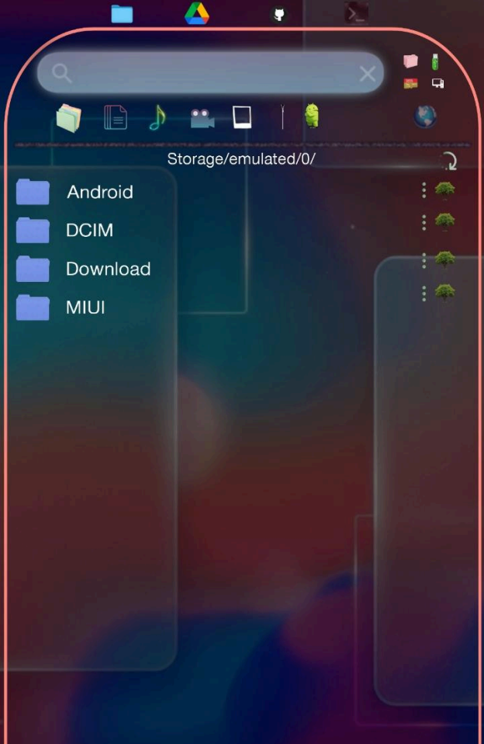

—-- ye ek panel Hai abhi ke liye.. Ye panel hain mobile storage panel … …
Lekin ye panel kisi ek ko dedicated nahi hain … . KyUnki humne panel ke upar 4 logo diye hain … ..

Ye panel kabhi kabhi kisi kisi me bhi convert Kar sakta hain user … .. - click karne per panel mobile storage ke liye available ho jaaye Drive logo - click karne per panel drive ke liye available ho jaaye …
甚- click karne per panel github k liy available ho jaaye
看 - click karne per panel terminal k liye available ho jaaye.
Esa Is liye kyuki agar kisiko ek sath Charo panel me hi import export karna ho to bhi Kar sake..
And agar all 4 panel difreently use karta hain like 1 for storage, drive, github, terminal to bhi ek hi panel me jitne chahe Utne drive, github, terminal, API, and storage me mobile storage, USB, otg, sd card sab ek sath bhi Kar paaye..
Account open ~ no limits … . (drive, github, storage, terminal)

Page 1 - of our Web app =
First we talk about all different scenarios … If a user uses all panel for different cloud … So First we talk about storage panel …
If a user click on Jo panel ke upar he

Jis bhi logo per click ho woh blink Hota Rahe … . Morden and professional animation ke sath … …
So panel will become a window of access of mobile storage panel … … ..

- MOBILE STORAGE PANEL

Ye panel mobile ke poore storage ka access degi sd card, mobile storage, otg, USB - - - Lekin utna hijitna mobiles ke rules allow kare basically mobile k file manager ka ye mirror hoga …
Mobile ka original system wala file manager jitna allow kare sab hamara ye panel allow
karega … .. - mobile ke system ke file manager ka ye mirror hoga … . Utna sab kuchh allow kare

jitna mobile android ke rule tode Bina user mobile file manager me Kar sakta hain sab allow kare … .all files folder and all extensions …

=======================

As you can see in the Pic …

Fol. Name  -  - | -  d/m/y h:m:s. : ◆

Time in 24 hours format … .

Above ~ folder panel jo ki sab folder ki hogi
- Is panel per single click karne per folder open hoga
- Long press karne per drag and drop ho activate ho jaaye, jab kisijagah drop ho to poocha jaaye

================================
“ what do you really want to do with this folder/file/anything?”

copy cancel move
================================

Ye dialog box ki size panel ke andar hi ho poore page ko cover na kare … (us panel me ho Jha pe drop Kara ho … ).....

- If user click on copy to sirf copy ho
- agar move per click kare to Jha se drag Kara hain waha se poori tarah se us folder ka naamo nisan hat ke Jha pe drop Kara hain waha pe chala jaaye..
d/m/y h:m:s (jab folder Ya file bani ho uski date or last modified date for files) : dots per click karne per folder rename, delete, compress,dfol (txt & pdf)
Rename ~

Jab rename per click ho to rename karne ka feature Esa ho jesa pc me Hota hain folder ke
pass hi ek empty box ban jaaye or usme naam likh sake and pass me cross and save ka button ho … .

× - click karne per rename cancel √ - click karne per rename ho jaaye
(also in system) theek usi wqt poori panel backend se mobile ke storage linked hoke refresh ho.

Koi bhi new activity ho all for panel usi wqt refresh ho editing replace delete rename or anything that relates to the files and folder. ( but not unnecessarily)
Format -
& agar sirf naam likha jaaye to folder bane
& Lekin naam ke baad dot lagake Jo bhi likha jaaye like txt, py, apk and universal format sab work kare

jisse format ka real Woking format bane Jo bhi formate user likhe hamari system woh format official level per professional system ke sath extreme original level ka format banaye us file ka …
Har ek format banane ke liye no. 1 engine or tools use ho for each and every format ke liye uske liye dedicated best tool available in the era.. Even for folder making … ..
And ye sare format ki file banane ke Liye original … . Engines Chale Jo real me original format ki file banaye naaki.. Just demo

===================

Delete ~
Click karne per ek final time verification poocha jaaye … cancel and conform
cancel - click karne per delete na ho Conform - click karne per ho jaaye..
IsKe liye bhi Professional engine ho … .
Or delete karne ka dialog box open ho woh panel ke andar panel ki size se andar Rahe naaki poore we page ko cover kare …
===========================

Compress
~

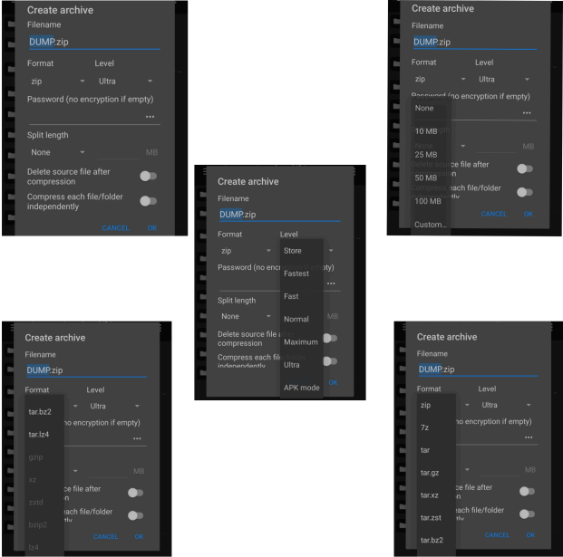

Ye features bhi set karate wqt sirf panel ko size ke andar hi Rahe Ese open ho naaki poore page ko cover kare …

Jitne bhi format he sabke liye ek dedicated top level ka no. 1 engine instemal ho.

===========================

dfol ~
Is feature ke sath jo : hain click karne per below features available ho …

Compress Folder
Live.txt
Live.pdf (including path and at the last tree)
~ agar koi : per click karke dfol per click kare to dfol ke pass me option menu me Jo Jo features select ho woh process ho …
Agar user all 3 tik karke rakhta hain to
Full folder . Zip
Live.txt
Live.pdf with file sabdump ho
In /storage/emulated/0/DUMP (YE FOLDER APNE AAP CRETE HO JAAYE FIRST dfol option use karne per..

And dfol per click karne per
Compression tool manager aaye … & save path following ho …
/storage/emulated/0/DUMP/TIME(JO HO WO) /
- FULL FOLDER - ZIP
- Live.txt & PDF

===============================
◆ - click karne per … like below

app.py 12/03/09 21:56:47 : ◆
—-----------------------------------------------------

If I click on tree … … …

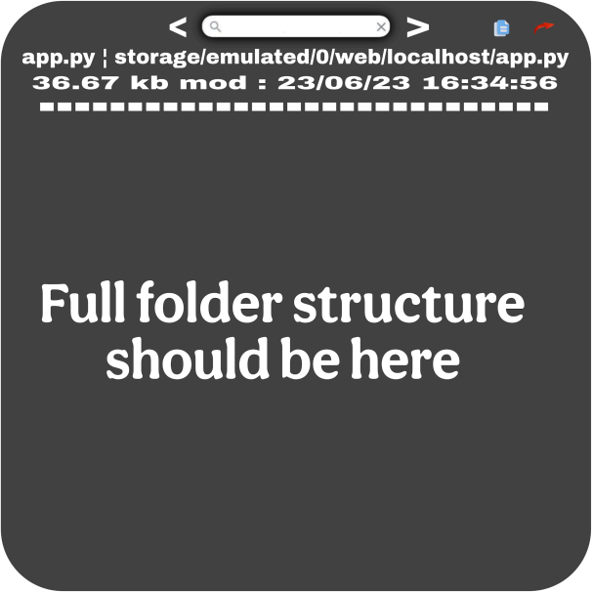

app.py likha hain woh file ka naam hain.. (file ke naam per click karne per file ka naam copy ho jaaye)
Storage/emulated/0/web/localhost/app.py is full path (is per click karne per full path copy ho jaaye)
36.67 kb is size (is per tap karne per copy ho jaaye)
Mod : 23/06/23 16:34:56 is last or latest modified date is per tap karne per copy ho jaaye..

Search bar : ye poori tree ke liye he …
- Jab koi file ke liye tree option open ho to sidha Jo file open ho woh portion per hi focus ho scroll hoke direct focus nahi ekdam fast but not so fast more than avarage scroll hoke us file per focus ho ke jaaye or uska color different rahe always … Jo bhi files ke liye tree open Kara ho.

- And searchbar woh file jaha pe bhi ho file us folder ka poora structure tree search Kar sake … search karke woh file name per tap karne per woh file open ho and uspe long press karne per us file. Ki properties dikhe … . Like below
If I search - Chakrarender.js
So tree focus kare sidha us file name per ROOT : /storage/emulated/0/WEB-VIM ├── 目 README.md
├── client
│ ├── static
│ │ ├── assets │ │ ├── css
│ │ │ └── cosmic-theme.css │ │ └── js
│ │ ├── Chakrarender.js
│ │ ├── gps-location.js
│ │ ├── live-tracker.js
│ │ ├── ui-controller.js
│ │ └── vimshottari-main.js │ └── templates

Then jab me ek baar Chakrarender.js per tap karu to sidha file open ho jaaye Lekin jab Chakrarender.js per long press karne per sidha us file ki properties open ho.. Like below -



Isme bhi same file name - Chakrarender.js per click karne per copy ho jaaye
Full path - /storage/emulated/0/WEB-VIM/client/static/js/chakra-renderer.js tap karne per copy ho jaaye … ..
Size - 324.56 kb tap karne per copy ho jaaye
Mod - 23-04-22 23:34:56 - per tap karne per copy ho jaaye … ..

Ab Jo file ke liye humne tree button press Kara he uska color to alag Rahe ga hi Lekin humne Jo search Kara woh highlight hoga..
agar koi mannualy scroll karke tree block ke kisi bhi file Ya folder k name per click kare … . Wo files Ya folder open Kar sake …

~~~~~~~~~

< SEARCHBAR >

Ye Jo searchbar ke dono side Jo arrow he inka kaam hoga ki maano Chakrarender.js search Karna he Lekin abhi tak mene sirf Chakra hi likha hain … . or file Ke andar
Chakrarender.js Chakra.js
chakra-renderer.py
Search bar ke andar kone me jitne letter likhe ho searchbar me unse match karate hue total exited files or folders ka count aaye like below

To agar ek naam ke multiple files ho to
< > ka use karke same name ke alag alag folder per jump Kar paaye …
> aage jaa paye. < pichhe jaa paye.



And cross per click karne per search baar bandh ho jaaye
~ And tree block me sabse upar Jha pe file ka naam likha Hai app.py user double tap karne per tree wapas file ke original name per focus ho jaaye …

~~~~~~~~~~~~~~



- is button per single click karne per poore tree ka structure copy ho jaaye … . & long
press karne per file ki properties and poora tree structure ko copy ho jaaye … - - - - - - - >
And jab ye copy karke jab paste kare tab ek professional format me bane naaki random Esa bhi feature ho … Badiya wala

~~~~~~~~~~~~~~~~

- is buton per click karne per poora tree with name /full path/size/mod date & and full folder structure tree txt/pdf me share ho sake … … And jab is button per click ho to poochha
jaaye selection ke uption aaye

Path - Mod -
Size - Tree -
Jo select ho wabi txt and pdf me print ho … .

~~~~~~~~~~~~~~~~~~~~~~~~

Drag & Drop ~
Jabbhi kisi folder per long press Kara jaaye to woh drag and drop ho paaye … Sath hi me woh below situation me lock ho jaaye … .

Jab drag and drop ke liye long press Kara jaaye tab Jis folder ko long press Kara hain uske alawa panel ke andar sab kuchh disable hoke main focus sirf long press kiye hue folder pe chala jaaye or wo highlight ho jaaye baaki sab blur ho jaaye.. 30% and above Pic me jesi situation dikhayi he Esi situation long press file folder ki ho jaaye …
Jisme highlight hue folder … … tab ke bicho bich ek button appear ho …
Jab first time user ko drag and drop karne ke baad wapas kisi or jagah drag and drop karna ho to usko long press wapas na karna pade bich wale button ko touch karate hi drag ho jaaye and drop Jha pe jitni baar karna ho Kar sake … .
Kyuki agar multiple jagah per ek ke baad ek drag a drop karna ho to … .. baar baar long press na karna pade … .
After completing the drop process folder ke end me cross button per click karne per wapas poori panel normal ho jaaye … …
Here is the 2 version of this feature - 1st {copy} ~

Agar kisi ne drag karke drop Kara or woh copy Kara ho.. To cross per click karne per wapas poori panel normal ho jaaye …
2nd {Move} ~
Lekin agar koi move kare to bhi folder/files apne panel se remove na ho … .. JaB user
highlighted folder ke cross per click kare or woh folder/files move Kari gai ho to user ko ek notification diya jaaye conformation karne ka usi panel ke size ke andar … …
Aapne is folder ko itnijagah per move Kar diya hain with list … . In that list ~
From ~Drive/github/terminal/storage
- Drive ho to Gmail + full path
- Git Hub ho to username + full path
- Terminal ho to API + full path
- Storage ho to sd/usb/local/others + full path

To ~ Drive/github/terminal/storage
- Drive ho to Gmail + full path
- Git Hub ho to username + full path
- Terminal ho to API + full path
- Storage ho to sd/usb/local/others + full path

to ab a ye folder sidha remove hoga is panel se kya aap chahe he Esa ho agar user conform per click kare to remove ho jaaye apni original jagah se …Warna agar cancel per click kare to naa ho and panel wapas normal ho jaaye.

==============================

To Iska first and root page hoga … like below

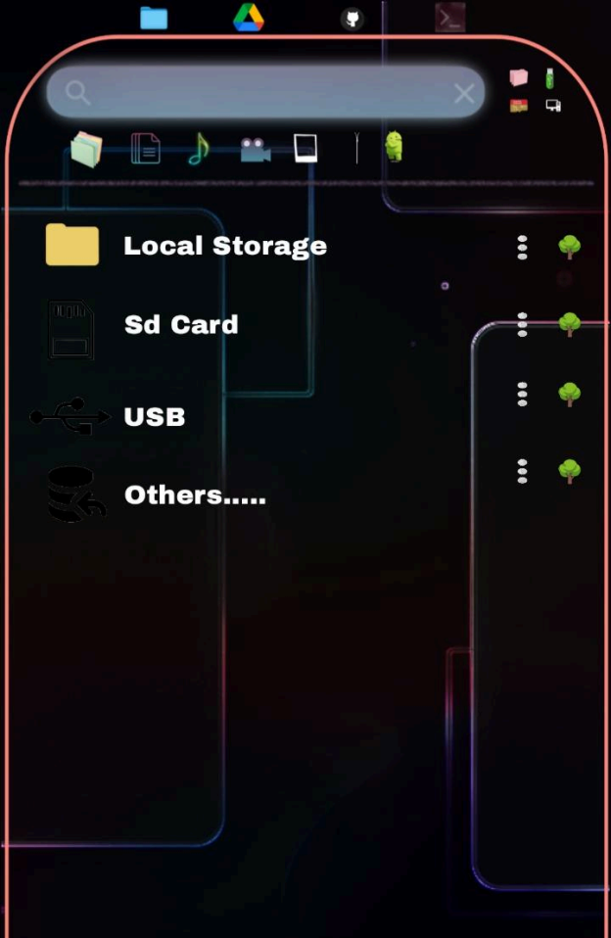

—---

~ Isme local storage, sd card, usb teeno per long press karke poora ka poora bhi drag and drop Kar sakte hain … …
Local storage ka Sara data just one click me kahi pe bhi drop Kara jaa sakta hain.. Also sd card & usb like below button …


Exatly wesa hi jesa humne above file folders me dekha … ..

( : ) ~ option menu per click karne per ~ Format
Click karne per poora sd/storage/usb delete
Lekin delete karne se pahele pochha jaaye are you sure? And conformation milne per jesa android system me Hota hain … . Delete hone se pahele 10 seconds ka countdown ho … . Uske baad hi poora sd usb storage delete ho …
Delete karne ke liye bhi industry standard engine ho … … .

~ dfol
Click karne per jesa humne above dekha wesa hi ho … poora ka poora sd card, usb, storage panel ka dump ban jaaye.

Zip
Live.txt + pdf
Full sd card/storage/usb

—------------------

Compress
~

Click karne per format select karke poora ka poora sd/storage/usb ki bhi zip Bana sake …

~ Access Control

STEP 3:
User taps "Access Control" NEW SCREEN / POPUP:

[ Access Control - SD Card ]
Mode:
If users click on ( ) Full Access he will able to allow below all things … .
[ √] View Files [ √] Open Files
File Actions: [ √] Copy
[ √] Move
[ √] Rename [ √] Delete
Creation:
[ √] Create File
[ √] Create Folder
Advanced: [ √] Share [ √] Upload
If user don't click on full access so users can also select mannualy only 2-3 permisons as per their wish …
If users click on ( ) Read Only he will able to allow below all things … . System auto changes:
[ √] View Files [ √] Open Files

[ √] Copy
[ x] Move
[ x] Rename
[ x] Delete
[ x] Create File
[ x] Create Folder [ x] Upload
If user don't click on read only so users can also select mannualy only 2-3 permisons as per their wish …
If user selects ( ) No Access ALL OPTIONS DISABLED SCREEN SHOWS:
"Access to SD Card is restricted"

============================== LIVE EFFECT
==============================

Now user opens SD Card panel:

CASE 1: Full Access → Everything works
CASE 2: Read Only → Can open files
→ Cannot delete / rename (buttons disabled)

CASE 3: No Access
→ Panel shows locked message → No files visible

==============================
USB (SAME FLOW)
==============================

[ Access Control - USB ]

Separate settings from SD Card Works independently

============================== IMPORTANT
==============================

- No Android permission changed
- Only my web app behavior controlled
- Works safely on all devices

=================
◆ ~
Ispe click karne per below type poora menu open ho …

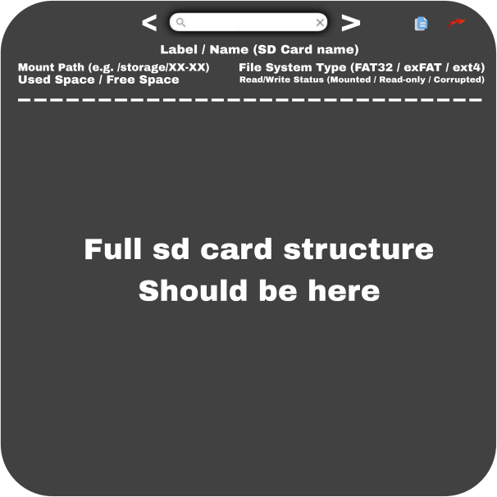

Label/Name - likha hain woh sd card ka naam hain.. (SD Card ke naam per click karne per card ka name copy ho jaaye)
Mount Path - Storage/emulated/0/xx-xx is full path (is per click karne per full path copy ho jaaye) Used Space /Free Space - per click karne per apne aap size copy ho jaaye.
Access control status - (Mounted-read only-courrpted) - click karne per above described access control ka whole status copy ho jaaye like below..
Status -

View Files : allowed
Open Files : not allowed Copy : not allowed
Move : not allowed
Rename : not allowed Delete : not allowed
Create File: not allowed Create Folder : allow
Share : not allowed Upload : allow
.
.
.
Rest all : allow/not allowed

========================

Search bar : ye poori tree ke liye he …
- Jab koi file ke liye tree option open ho to sidha Jo file open ho woh portion per hi focus ho scroll hoke direct focus nahi ekdam fast but not so fast more than avarage scroll hoke us file per focus ho ke jaaye or uska color different rahe always … Jo bhi files ke liye tree open Kara ho.

- And searchbar woh file jaha pe bhi ho file us folder ka poora structure tree search Kar sake … search karke woh file name per tap karne per woh file open ho and uspe long press karne per us file. Ki properties dikhe … . Like below

If I search - Chakrarender.js
So tree focus kare sidha us file name per ROOT : /storage/emulated/0/WEB-VIM ├── 目 README.md
├── client
│ ├── static
│ │ ├── assets │ │ ├── css
│ │ │ └── cosmic-theme.css

│ │ └── js
│ │ ├── Chakrarender.js
│ │ ├── gps-location.js
│ │ ├── live-tracker.js
│ │ ├── ui-controller.js
│ │ └── vimshottari-main.js │ └── templates

Then jab me ek baar Chakrarender.js per tap karu to sidha file open ho jaaye Lekin jab Chakrarender.js per long press karne per sidha us file ki properties open ho.. Like below -



Short and sweet ~ humne above jese files folder ke liye tree system banaya hain same to same root page ke sd card usb and whole local storage ke sath bhi woh Kar paaye … .

==============================

Refresh button -
Sare folder ke tree option ke upar panel refresh button hain user click karne per woh poore Jo bhi open ho ( SD Card, local storage, usb) poora ka poora refresh kare … …
And us button per long press karne per auto refresh ka time set Kar paaye user
(10sec to as long as user wants) time set karke done per click karne per set ho jaaye..
IsKe liye bhi special dedicated engine ho …
>> refresh ke left side path likha Hai. Woh cureent open folder ka path he … like now I am in localhost folderso Paths should be..
/storage/emulated/0/WEB-VIM/localhost/

Then I tap on emulated so sidha emulated per page per chala jaau.. Direct jump jesa android mobile file manager me Hota hain..

=============================

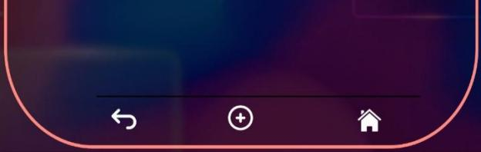

First button - back jaaane ke liye as usual jesa android me Hota Hai … .
Middle button - is per long press karne per create folder ka option aaye.. Jo panel ki Size ke andar open ho …
× √
Cross per click karne per poori process cancel ho jaaye …
And name likh Kar right per click karne per folder save ho jaaye …
And agar kisi ko file banani hi to jesa humne above discuuss Kara hain … . Ki Name ke pichhe dot lagake Jo bhi extension likhe Esi hi file ban jaaye profession tools and engine ki Madad se …
- single click karne per sidha first page per chala jaaye user … Agar user local storage/sd card/usb me ho to … .
Android
DCIM
DOWNLOAD

But long press kare to sidha root page per aa jaaye..
崮 - sd card
- Local storage

- usb / pendrive

================================

Search bar..

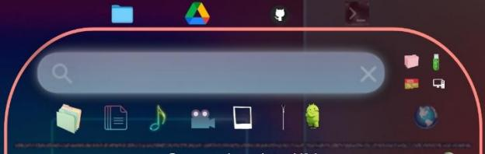

Ye Jo search bar hain woh panel ke liye universal hain … and ye search bar ke liye ek alag engine ho Jo Isko dedicated ho … Sirf ek letter likhne per suggestion start ho jaaye..

Lekin seaclrch baar ke niche Jo sare extension/format ke logo he woh … & left side Jo logos hain woh is search baar ke liye filter Kam karenge …
Imagine a user inside of /storage/emulated/0/WEB-VIM/localhost (local storage)
Ab woh chahta hain.. Ki use sd card ke download folder se koi file or folder ko move karna hain …

To woh again & again back button dabake local storage se Bahar nikal Kar wapas sd card me jaake picture folder open kare usme time waste kare Isse achha hain..

Woh sidha … search baar ke left side Jo 4 logos diye hue he …
- Local storage
凸 - sd card - usb
Other - pc or any connection..
To woh sd card logo per click kare and turant hi woh logo highlight ho jaaye … Ab use sirf search baar me kuchh bhi search karna hain … Use sirf sd card ke hi result dikhenge …

Ab user ne sd card to select Kar Liya..
Lekin user ko agar local storage /sd card/usb/other-pc or anything me se bhi search karna hain to … Sirf glob button per click kare (earth) and ab woh highlight ho jaayega ab woh poori panel ko search Kar sakta hain … .. With use us of search bar ke niche Jo folder diye hain Unka use karke..
圖 Π 豐 斷 鱻 圖
Globe select Kar Liya … .. AnAnd user ko sirf video hi find karna hai jo just select video logo woh highlight ho jaayega and ab use globbaly sd/localstorgae/pc/usb me se sirf videos hi
suggestion me aayenge …
To ab user sd card select karne ke baad search bar me likhega … download folder aayega …
Ab user ko download folder me se sirf koi pictures hi chahiye … . (Lekin download folder to poora bhara hua Hota hain … )
To user search bar ke niche (as you can see in the Pic) Jo logos diye hue hain unemse folder folder / pictures dono logo select karega.. Select karate hi highlight ho jaayenge. Dono logos..
- folders √ 圖 - files
Π - music
豐 - video
斷 - image √ 鱻 - Zip
圖 - application
Ab user search bar me download search karega to user sirf download folder and download folder ke sare pictures hi dikhenge..
Kyuki download folder to bin ki tarah Hota hain … . KaKai sari chheeze to user ko download likhne per Kai sari cheese dikh sakti hain Lekin ye filter usko help karenge.. Uska kaam easy karne ke liye..

Also we will add one more feature … like below.. User ne likha ~ trashed
To niche Kai sare pictures aa Gaye.. trashed_ naam wale to Lekin generally images ke naam to below type hote he..

.trashed-1776510808-Screenshot_2026-03-19-16-33-28-307_com.termux.jpg .trashed-1776659066-Screenshot_2026-03-20-17-34-39-647_bin.mt.plus.jpg .trashed-1776857080-IMG_20260321_095340.jpg

Ism user confuse ho sakta hain.. To user ko name ke pass me image dike Jo ekdam clear ho … . Jese sab file manager me Hota hain wese hi..

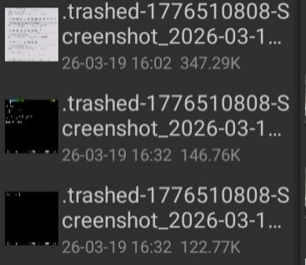

And us picture per click karne per woh poora picture dikhe ek chhoti size ka jisse woh conform Kar paaye ki ye wahi hain.. Jo move Ya copy karna chahta hain..
Videos bhi same ese hi dikhe. Play ho paaye … … .
Ese hi same pdf and text bhi load ho paaye panel ke andar jisse user conform Kar sake … .

~~~~~~~~~~~~~~~~

AB SABSE IMPORTANT JAB USER KOI CHHEEZ SEARCH KARE TO USER KISI CHHEEZ K
SATH KOI TASK KARNE KE LIYE US FILE YA FOLDER ME NAA JAANA PADE WOH SEARCH BAAR SE HI SAB KAR PAAYE..
ABHI JESA HUMNE trashed search Kara or sare pics suggestion me aa gaye.

To ye sare bhi ese hi kaam kare jese hum folder ke andar ho.. Mene search Kara > trashed … .
To suggestion below type honge.

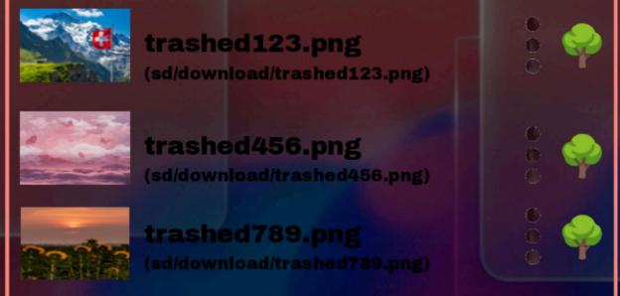

1 - Pic per click karne per Pic/file ho bhi ho wo poora dikhega lekin panel ke andar
2 - one time click karne per Pic or file Jo bhi ho uske andar jaa paoge.
3 - (:) & & ◆ per click karne per woh sare features Jo humne upar alaredy discuss kare hain (our main is ki user ko search baar se hi woh sab Kar sake Jo folder ke andar jaake Kara jaa sakta Hai … IsIsi liye search baar se aaye hue suggestion se hi sab ho jaaye jisse user search
bar se hi kaam kahtam kare use folders ke andar jaake time waste na karna pade)

4 - long press karne per above Jo humne disccus Kara wesa ho jaaye like below..



Yahi se hi move copy ho paaye..

================================



================================

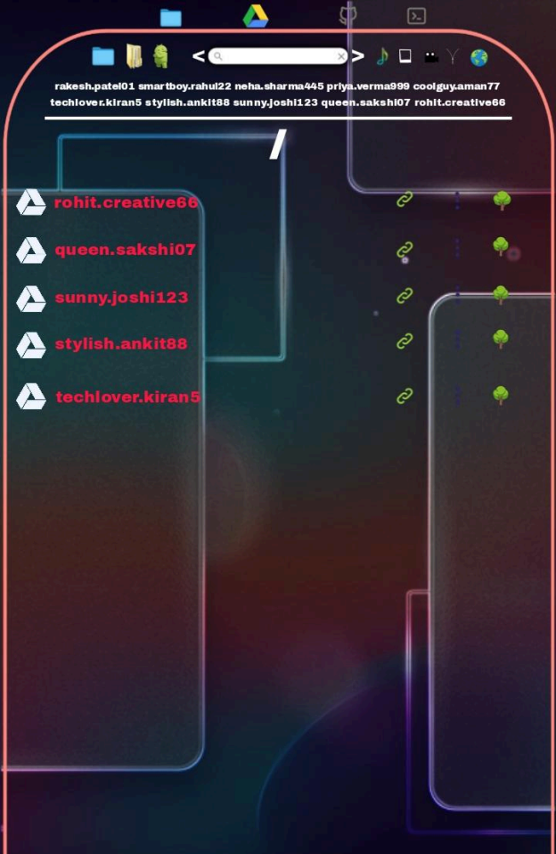

… . Agar user panel ke upar drive ke logo per click karta hain to ye panel me user google drive account ko access & manage Kar sakta hain … ..
Panel me sabse niche
↪ Jisme user cureent page se back jaa sakta hain … ..
➕ Click karne per create folder & add account ka option aaye..
~ single click karne Jis Gmail ke andar ho uske root page per aaye … .. LongLong press karne panel ke root page per jump ho jaaye.
~~~~~~~~~~~~~~~~~~~~~~~~~~~~~~~

================================
Gmail.com 图 : ◆
================================
= yaha pe drive me jo user ne dp rakhi woh load ho agar warna by default jo account me dp ho woh load ho …
Gmail.com - yaha gmail account ka name dikhe only No @gmail.com like sunny.joshi123
图 - single click per full Gmail id copy ho jaaye with @gmail.com like sunny.joshi123@gmail.com
Long press karne per - panel ke size ek dialogue box open Ho jisme drive account ke andar ki har cheez ko select karke unko bulk me ek sath sabka agar public ya email koi bhi access dena ho de sake …
(ye poora system Create karna hoga jitne bhi type ke access drive deta ho sab access bulk me de sake..)

~~~~~~~~~~~~~~~~~~~~~~~~~~~~~~~~

{:} - click karne per above Humne jesa discuss Kara sab kuchh ho jo local storage me features he sab
In drive panel we will add one more features.. -jisme tumhe gmail id na dikhani ho screen per to koi random Naam rakh sakte ho for panel..
1. Gmail name se ek feature ho jis per click karn per Gmail ko hide karke uskijagah name show kar paaye. Ye feature me password optional ho jab user Gmail ko koi name de tab agar password dale save kare to Gmail show hi na jab tak password na dala jaaye tab tak real Gmail id show na ho …

2. And Jab tum first time google account add karo tabhi poocha jaaye … Agar koi name set karna ho to … . With password jisse tum apna original Gmail account chhupana ho to
chhupa sako … Ye feature me password optional ho jab user Gmail ko koi name de tab agar password dale save kare to Gmail show hi na jab tak password na dala jaaye tab tak real Gmail id show na ho …
◆ - click karne per above humne jesa dicuss kara sab kuchh jo local storage features he sab In drive panel for tree feature we will add one more feature in properties … like below … .
Jab Gmail koi name na diya gaya ho tab :

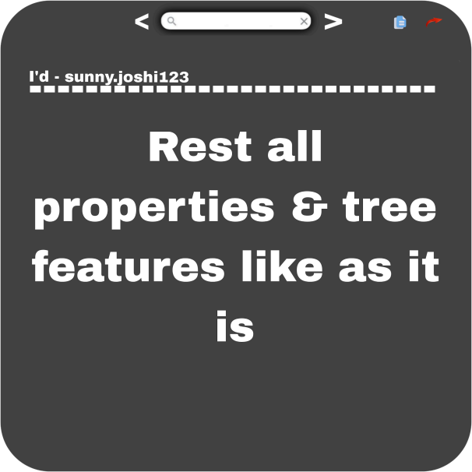

Jab Gmail ko Naam diya gaya ho tab :

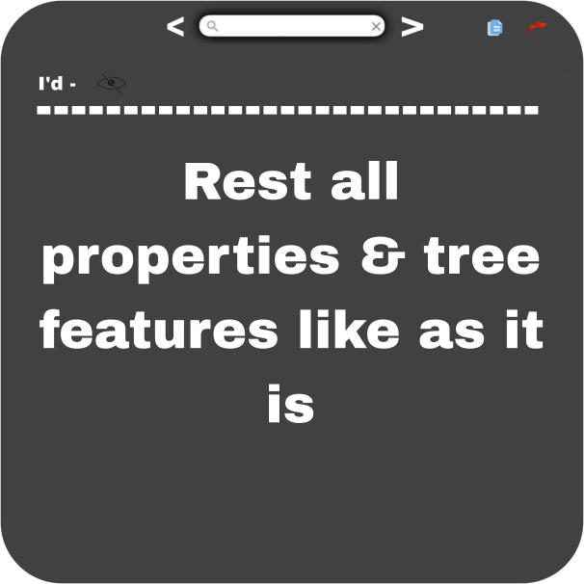
Jab eye per click ho tabhi show ho gmail id (pass me copy button ho jisse user copy kar paaye &. Copy karne per Sirf sunny.joshi123 nahi poora sunny.joshi123@gmail.com copy ho)
Jab Gmail ko name deke password se lock kara gaya ho tab

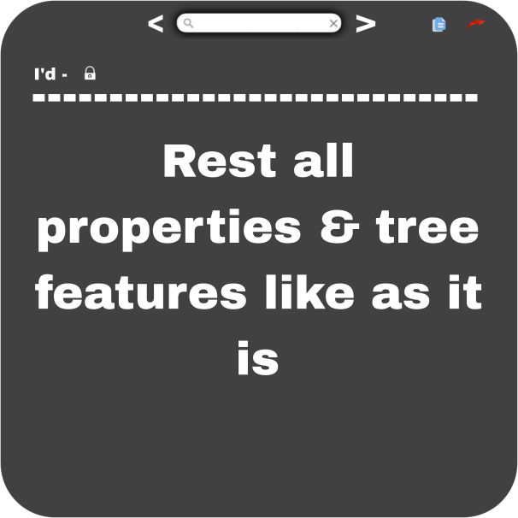

Dekhneke liye lock per click karne per wahi per password manga jaaya password dalne per
Gmail id show ho … . (pass me copy button ho jisse user copy kar paaye &. Copy karne per Sirf sunny.joshi123 nahi poora sunny.joshi123@gmail.com copy ho)

~~~~~~~~~~~~~~~~~~~~~~~~~~~~~~~~

/ - searchbar ke niche jo hai ye current path dikhata hain … AbHi hum root page per he to / show ho raha hain jab kisi Gmail ke andar chale jaayenge tab /gmail.com show hoga …

Let's suppose … . NoW I am in python folder so that / jagah following dikhega..

/sunny.joshi123@gmail.com/A1/server/localhost/panel/python
Ab muje drive ke sabse first page yaani drive ke root per jana hain to I will directly click on sunny.joshi123@gmail.com and sidha me account ke first page per jump kar jaunga …

~~~~~~~~~~~~~~~~~~~~~~~~~~~~~~~~

Searchbar -
Ke niche jo Gmail id’s likhe he woh filters ke liye hain … . Jis bhi Gmail ko select karo woh
highlight ho jaayega and searchbar sidha us Gmail id account se hi cheeze dikhayega … .. AgAr sabko select karoge to sabse filter karega in
Our system operates without acknowledging the existence of limits or constraints.
Also searchbar ke pass pass jo format/extension like image, app, video etc ke jo logo hain woh bhi search ke filter hain like above as we show in local storage … …

================================

